DIS-ME-Tel Halaf terracotta fertility idol ca. 6100-5400 B.C.E.

Tel Halaf terracotta fertility idol ca. 6100-5400 B.C.E.

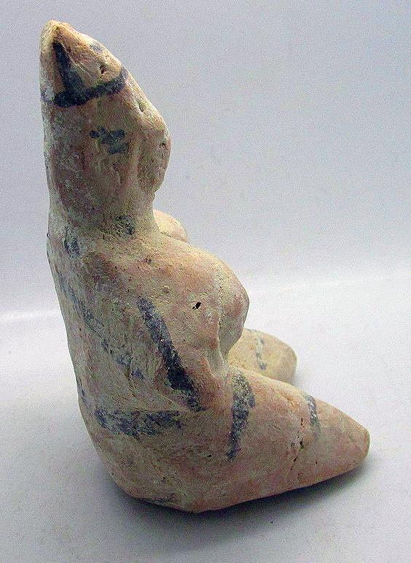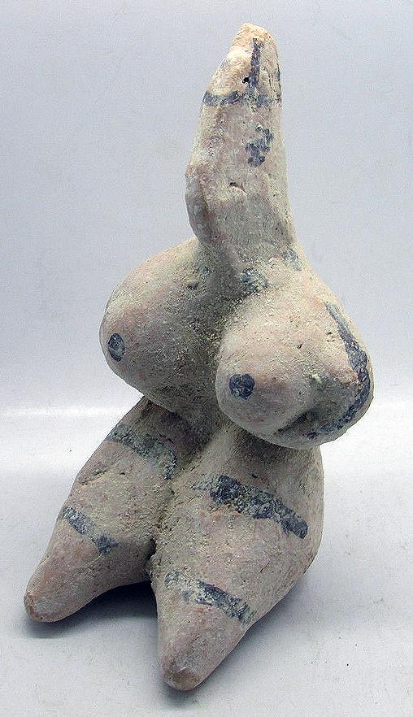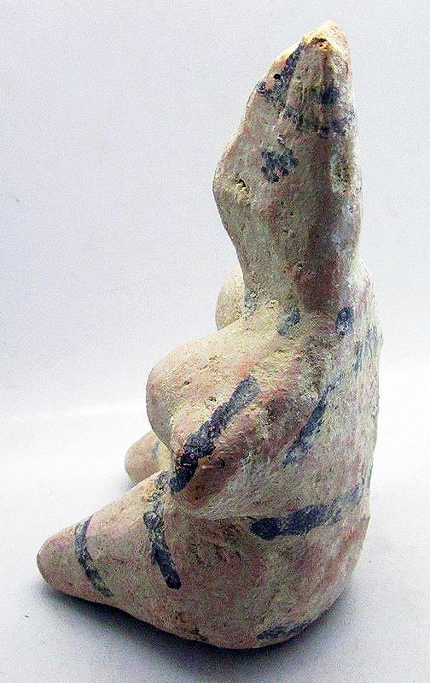

Sold by [mikes-artefacts](http://myworld.ebay.com/mikes-artefacts) ( [546](http://feedback.ebay.com/ws/eBayISAPI.dll?ViewFeedback&userid=mikes-artefacts) )

### Delivery package 1 of 1

Estimated delivery Friday, Jan 22, 2016 - Friday, Jan 29, 2016

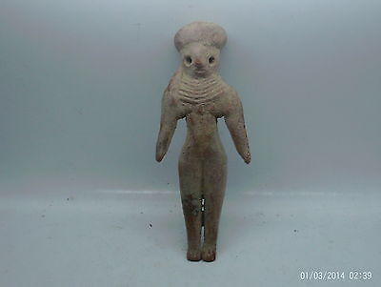

#### [Rare ancient Indus valley harappa terracotta fertility idol 2000BC](http://www.ebay.com/itm/151922619863)

|  |  |
| --- | --- |
| Item price | GBP 90.00 |
| Quantity | 1 |
| Item number | 151922619863 |
| Shipping service | Royal Mail International Tracked |

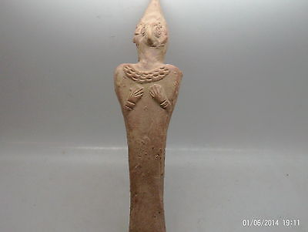

#### [Superb ancient Syro hittite terracotta fertility idol 1100-800BC](http://www.ebay.com/itm/151926987220)

|  |  |
| --- | --- |
| Item price | GBP 200.00 |
| Quantity | 1 |
| Item number | 151926987220 |
| Shipping service | Royal Mail International Tracked |

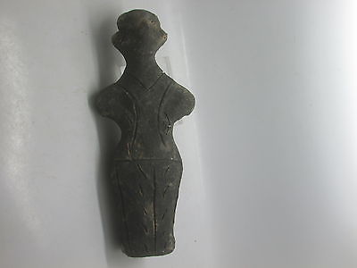

#### [Very rare Neolithic Prehistoric Vinca figurine 5700-4500BC](http://www.ebay.com/itm/151928683199)

|  |  |
| --- | --- |
| Item price | GBP 300.00 |
| Quantity | 1 |
| Item number | 151928683199 |
| Shipping service | Royal Mail International Tracked |

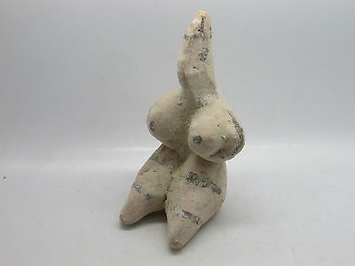

#### [Ancient Tel Halaf terracotta fertility idol C. 6100-5400BC](http://www.ebay.com/itm/151944451769)

|  |  |
| --- | --- |
| Item price | GBP 125.00 |
| Quantity | 1 |
| Item number | 151944451769 |
| Shipping service | Royal Mail International Tracked |

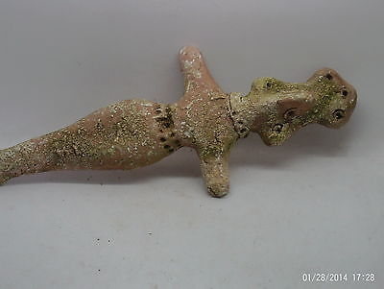

#### [Superb Syro hittite terracotta figurine 1000BC](http://www.ebay.com/itm/151945844875)

|  |  |
| --- | --- |
| Item price | GBP 150.00 |
| Quantity | 1 |
| Item number | 151945844875 |
| Shipping service | Royal Mail International Tracked |

## Shipping address

Ralph J Coffman Jr

149 Atlantic Ave

Swampscott MA 01907-2427

United States

## Order total

|  |  |
| --- | --- |
| Subtotal | GBP 865.00 |
| Shipping | Free |

**Total**

GBP 865.00